AHEAD PROGRAM COMMUNICATIONS TOOLKIT
September 2025

This communications toolkit is designed to help our members and their partners share the good news of winning an AHEAD grant with their stakeholders and local media.
To kick off 2025 AHEAD grant communications, FHLBank San Francisco will issue a news release announcing the grants and amplify the announcement with a LinkedIn post highlighting the benefits of the grants in the communities our members serve. The Bank encourages members and partners to share/like/repost our LinkedIn post and consider publishing your own news releases and social posts. To support these efforts, the Bank’s marketing communications team is available to support your promotional efforts, including by reviewing your draft press release(s) and/or social media content. Please contact Chris Hammond on FHLBank San Francisco’s marketing and communications team for support.
Please find helpful elements for your award promotion below.

AHEAD Program Key Messages
- In 2025, the Bank FHLBank San Francisco responded to extraordinary demand for AHEAD Program grants in its three-state district with an increase in voluntary funding for the program to $8 million, up 10% over funding for the program in 2024.
- With this funding, 40 FHLBank San Francisco members, four of which are participating in the program for the first time, will deliver individual AHEAD grants of up to $150,000 to 64 impactful projects that are aimed at boosting local economic development initiatives across Arizona, California, and Nevada.
- Since the AHEAD program’s inception in 2004, the Bank has awarded over $40 million in AHEAD grants to nearly 940 economic vitality projects in Arizona, California, and Nevada.
- For 21 years, FHLBank San Francisco and its members have delivered grants that support economic vitality in underserved communities. AHEAD grants fund innovative, targeted initiatives that will create new economic opportunity.
- AHEAD Program grants support projects or initiatives that benefit low- to moderate-income communities by creating or preserving jobs, delivering job training or education programs, supporting small business, microlending, and microenterprise incubation for low-income entrepreneurs, addressing the special economic development needs of at-risk youth, veterans, persons with disabilities, the formerly incarcerated, and tribal communities, among other underserved groups.
- Details about 2025 Awarded Projects are available on the Bank’s public website.
- More information for members who may wish to participate in the future, such as project eligibility, can be found on FHLBank San Francisco’s AHEAD web page. For additional information, please email the AHEAD program team or call (415) 616-2542.

Logos
FHLBank San Francisco’s logo is available for download and use on participating member and sponsor websites. To access downloadable formats and usage guidelines, visit: https://www.fhlbsf.com/about-us/press-kit#logos

FHLBank San Francisco Naming Conventions
When referencing FHLBank San Francisco, please use the Bank’s full name, Federal Home Loan Bank of San Francisco, or the approved shortened logo version, FHLBank San Francisco (please note that there is no “the” or “of” in the shortened version).

FHLBank San Francisco Boilerplate Descriptor
The Federal Home Loan Bank of San Francisco is a member-driven cooperative helping local lenders in Arizona, California, and Nevada build strong communities, create opportunity, and change lives for the better. The tools and resources we provide to our member financial institutions — commercial banks, credit unions, industrial loan companies, savings institutions, insurance companies, and community development financial institutions — propel homeownership, finance quality affordable housing, drive economic vitality, and revitalize whole neighborhoods. Together with our members and other partners, we are making the communities we serve more vibrant and resilient.

News Release Template (Members)
DRAFT – NOT APPROVED FOR RELEASE
Sample mission/impact headline statements:
“Provide Workforce Training for Underserved Students”
“Improve Housing Conditions on Tribal Lands”
[Financial Institution] Partners with FHLBank San Francisco to Award [Nonprofit] a [$ Amount] Grant to [Brief Statement of Nonprofit Mission/Community Impact]
LOCATION – DATE, 2025 – [Financial Institution], in collaboration with the Federal Home Loan Bank of San Francisco (FHLBank San Francisco), will deliver a [$ amount] AHEAD Program grant to [nonprofit].
[Financial institution] applied for the grant in partnership with [nonprofit]. After a competitive selection process, [Nonprofit] was awarded the AHEAD Program grant to fund [nonprofit]’s work to [nonprofit mission or project]
[Note: consider referencing the number of years and or times your organization has been awarded an AHEAD Program grant]
[Background on nonprofit and/or the project funded]
“….QUOTE HERE…,” said [Financial Institution Representative]. “CONTINUE QUOTE HERE….”
AHEAD grants enable FHLBank San Francisco members like [Financial Institution] to give a critical boost to local economic development programs and projects that directly address pressing needs in low- to moderate-income communities.
“In this year’s highly competitive application cycle, we received 400 AHEAD grant proposals, underscoring the widespread need for support to drive local economic vitality across our district,” said Eric Cicourel, Community Investment Officer at FHLBank San Francisco. “We are proud to partner with [Member Name] in awarding this grant to [Sponsor Name], recognizing the important work they do in their community. AHEAD is a voluntary grant program and a benefit of FHLBank San Francisco membership that reflects our broader mission to be a dependable source of liquidity for community lenders and a catalyst for housing and economic development in the communities we serve.”
[If not including the quote above, add this sentence to paragraph below: XYZ project was awarded a 2025 AHEAD Program grant as part of a competitive process that attracted more than 400 applications.]
For those interested in applying for the AHEAD Program in 2026, please contact [Financial Institution] or visit the FHLBank San Francisco website to learn more.
About Financial Institution
Financial institution boilerplate
About Nonprofit Institution
Nonprofit institution boilerplate
About the Federal Home Loan Bank of San Francisco
The Federal Home Loan Bank of San Francisco is a member-driven cooperative helping local lenders in Arizona, California, and Nevada build strong communities, create opportunity, and change lives for the better. The tools and resources we provide to our member financial institutions — commercial banks, credit unions, industrial loan companies, savings institutions, insurance companies, and community development financial institutions — propel homeownership, finance quality affordable housing, drive economic vitality, and revitalize whole neighborhoods. Together with our members and other partners, we are making the communities we serve more vibrant and resilient.
# # #

News Release Template (AHEAD Grant Recipient)
DRAFT – NOT APPROVED FOR RELEASE
Sample mission/impact headline statements:
“Provide Workforce Training for Underserved Students”
“Improve Housing Conditions on Tribal Lands”
[Nonprofit] Awarded a [$ Amount] Grant to [Brief Statement of Nonprofit Mission/Community Impact]
[Member Financial Institution] Partners with FHLBank San Francisco to Award AHEAD Grant to Boost Economic Development [in City/Community]
LOCATION – DATE, 2025 – [Nonprofit] will receive a [$ amount] grant in support of its [nonprofit mission or project], awarded by the Federal Home Loan Bank of San Francisco (FHLBank San Francisco) AHEAD Program in partnership with [Member Financial Institution].
[Nonprofit] collaborated with [Financial Institution] to receive the grant from FHLBank San Francisco to apply for the grant. The AHEAD Program enables FHLBank San Francisco members like [Financial Institution] to give a critical boost to local programs and projects that target pressing community needs and bring greater opportunity to underserved populations.
[Background on nonprofit and/or the project funded]
“….QUOTE HERE…,” said [Project Sponsor Representative]. “CONTINUE QUOTE HERE….”
[Financial institution] partnered with [nonprofit] to apply for the grant that was awarded in the [$ amount] to fund [nonprofit]’s work to [nonprofit mission or project] after a competitive selection process with over 400 applications submitted.
[Note: consider referencing the number of years and or times your organization has been awarded an AHEAD Program grant]
“….QUOTE HERE…,” said [Financial Institution Representative]. “CONTINUE QUOTE HERE….”
AHEAD grants enable FHLBank San Francisco members like [Financial Institution] to give a critical boost to local economic development programs and projects that directly address the needs in low- to moderate-income communities.
“In this year’s highly competitive application cycle, we received 400 AHEAD grant proposals, underscoring the widespread need for support to drive local economic vitality across our district,” said Eric Cicourel, Community Investment Officer at FHLBank San Francisco. “We are proud to partner with [Member Name] in awarding this grant to [Sponsor Name], recognizing the important work they do in their community. AHEAD is a voluntary grant program and a benefit of FHLBank San Francisco membership that reflects our broader mission to be a dependable source of liquidity for community lenders and a catalyst for housing and economic development in the communities we serve.”
For those interested in applying for the AHEAD Program in 2026, please contact [Financial Institution] or visit the FHLBank San Francisco website to learn more.
About Financial Institution
Financial institution boilerplate
About Nonprofit Institution
Nonprofit institution boilerplate
About the Federal Home Loan Bank of San Francisco
The Federal Home Loan Bank of San Francisco is a member-driven cooperative helping local lenders in Arizona, California, and Nevada build strong communities, create opportunity, and change lives for the better. The tools and resources we provide to our member financial institutions — commercial banks, credit unions, industrial loan companies, savings institutions, insurance companies, and community development financial institutions — propel homeownership, finance quality affordable housing, drive economic vitality, and revitalize whole neighborhoods. Together with our members and other partners, we are making the communities we serve more vibrant and resilient.
# # #

Social Media Sample Post
Social handles: LinkedIn and Facebook @Federal Home Loan Bank of San Francisco
Graphic:
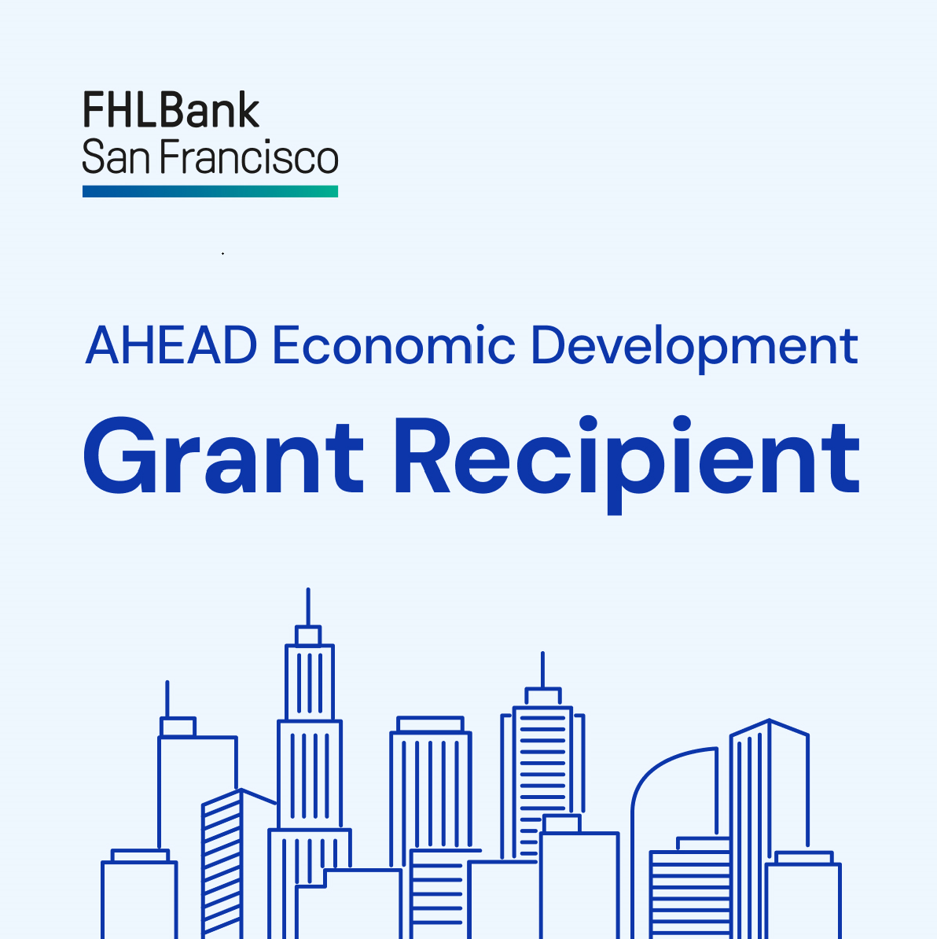 | Downloadable file for LinkedIn at 1200 x 200  Screen shot of social media graphic.  Members and sponsors are welcome to insert logos aligned with FHLBank San Francisco in the center and or right justified

Hashtags: #AHEAD #Grant #EconomicDevelopment #CommunityDevelopment
Member Sample Social Copy
@Financial is proud to deliver a 2025 AHEAD Program grant in the amount of $## in partnership with @Federal Home Loan Bank of San Francisco to @Nonprofit to help boost economic vitality in [Geography]. Learn more: [Link to news release].
Sponsor Samples Social Copy
[Name Nonprofit] is a 2025 AHEAD Program grant winner and will be awarded a grant in the amount of $## delivered by [Name Financial Institution] in partnership with @Federal Home Loan Bank of San Francisco.
These grant funds will support [Name Project/Description] Learn: Link to news release

# # #

For additional information, please contact Chris Hammond with FHLBank San Francisco’s marketing and communications team.

